Can quantitative macroe-financial regime signals improve the dynamic allocation of equity factors out of sample after transaction costs?
Modify 1:
M1 Growth × Inflation
M1 regime | Definition | Months | Share
Expansion | High growth + low inflation | 102 | 23.4%
Overheating | High growth + high inflation | 89 | 20.5%
Slowdown | Low growth + low inflation | 115 | 26.4%
Stagflation | Low growth + high inflation | 129 | 29.7%
Total |  | 435 | 100%

Regime | MKT-RF | SMB | HML | RMW | CMA | MOM
Expansion | 1.211 | 0.122 | -0.120 | -0.002 | 0.008 | 0.847
Overheating | 0.132 | -0.445 | 0.830 | 0.666 | 0.635 | 0.791
Slowdown | 0.614 | 0.255 | -0.371 | 0.015 | 0.240 | 0.334
Stagflation | 0.981 | 0.255 | 0.418 | 0.622 | -0.080 | 0.079
Expansion has the highest market return at 1.211% and strong momentum at 0.847%.
Overheating is quite different: market return falls to only 0.132%, while HML, RMW, CMA and MOM are relatively strong.
Slowdown shows negative HML (−0.371%) and much weaker MOM than Expansion/Overheating.
Stagflation has strong RMW (0.622%) but almost no momentum (0.079%).

M1 simply says:
Growth dimension = industrial production growth
Inflation dimension = inflation
and splits the two dimensions into four regimes.
Much cleaner.

M2 Growth × Pressure
M2 regime | Months
Strong Growth / Low Pressure | 128
Weak Growth / Low Pressure | 115
Weak Growth / High Pressure | 108
Strong Growth / High Pressure | 84
Issue 1 — M2 is more subjective than it initially appears
After standardization,
Growth Index = IP growth + term spread − unemployment
Pressure Index = VIX + credit spread + inflation + |2Y Treasury change|
“Why these signs?”
“Why equal weights?”
“Why is inflation part of pressure?”
“Why absolute Treasury change?”
“Why should unemployment and term spread receive exactly the same weight?”

Issue 2 — M2 may overlap too much with your predictive model
Predictive models already use the seven macro variables.
Then M2 uses essentially those same seven variables to define the regime.
So the structure starts becoming:
7 macro predictors → construct regimes
and also:
same 7 macro predictors → predict factor returns
That isn't automatically wrong, but it makes the empirical design less clean.
With M1, the regime definition is a relatively simple economic state variable, while your richer predictor set can separately be used for forecasting.

M3 PCA + K-means
Criterion | M1 Growth × Inflation | M2 Growth × Pressure | M3 PCA + K-means
4 regimes obtained | ✅ | ✅ | ✅
Uses all 7 variables | ❌ | ✅ | ✅
Regime sizes balanced | Excellent | Excellent | ❌ Poor
Smallest group | 89 | 84 | 11
Economic interpretation | Excellent | Good | Weak/moderate
Factor-return differences | Clear | Clear | Very large but partly driven by extreme cluster
Researcher choices | Relatively low | Higher | Higher
Outlier sensitivity | Low/moderate | Moderate | High in your result
Easy to explain | Excellent | Good | Harder
Main model | ⭐⭐⭐⭐⭐ | ⭐⭐⭐⭐ | ⭐⭐
Robustness check | Yes | Yes | Yes

Factor | ANOVA p | Kruskal p | Conclusion at 5%
MKT-RF | 0.3414 | 0.2429 | No significant evidence
SMB | 0.3288 | 0.1203 | No significant evidence
HML | 0.0361 | 0.1279 | Mixed evidence
RMW | 0.1108 | 0.0252 | Mixed evidence
CMA | 0.0941 | 0.1816 | No 5% evidence
MOM | 0.5592 | 0.9756 | No significant evidence
There is selective rather than universal evidence of regime dependence. HML exhibits significant differences under the parametric ANOVA test, while RMW exhibits significant differences under the non-parametric Kruskal–Wallis test. The remaining factors do not show statistically significant cross-regime differences at the 5% level.
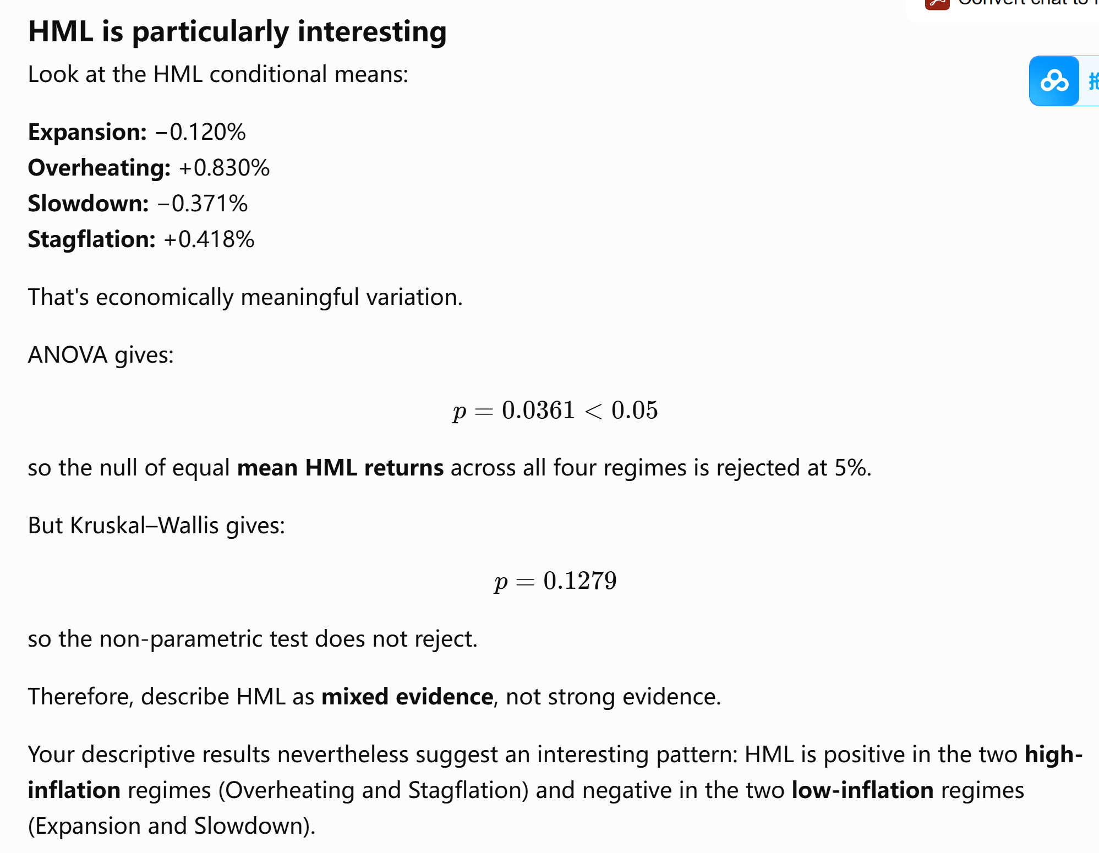
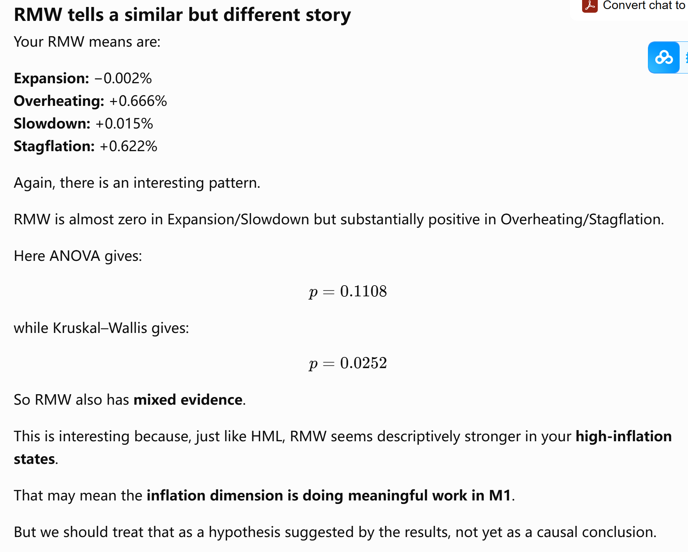
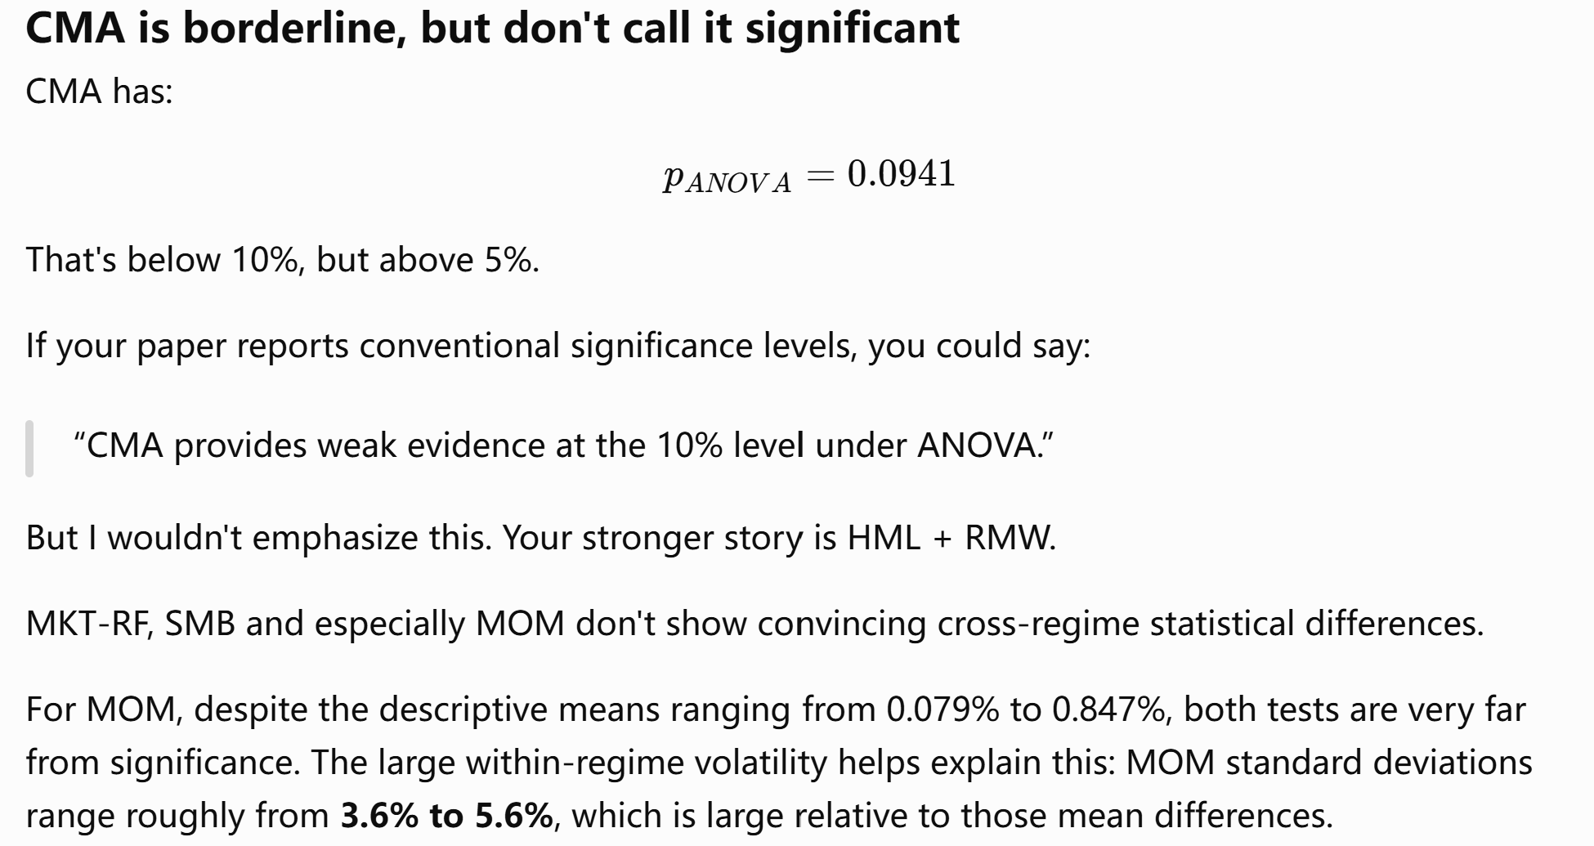

Variables:
Category | Variable | Role | Transformation / timing | Interpretation
Market condition | VIX | Predictor | Monthly average at $t$ | Equity-market uncertainty / fear
Credit condition | Credit_Spread | Predictor | Monthly average at $t$ | Corporate credit-risk condition
Yield curve | Term_Spread | Predictor | Monthly average at $t$ | Slope of Treasury yield curve
Interest-rate movement | Treasury_2Y_change | Predictor | $Δ$2Y yield at $t$ | Monthly change in short-term rates
Inflation | Inflation_lag1 | Predictor | CPI growth lagged one month | Inflation information available to investors
Labor market | Unemployment_lag1 | Predictor | Unemployment rate lagged one month | Labor-market condition
Real economy | IP_Growth_lag1 | Predictor | Industrial production growth lagged one month | Real economic activity
Market factor | MKT_RF_next | Target | $$t+1$$ | Next-month market excess return
Size factor | SMB_next | Target | $$t+1$$ | Next-month small-minus-big return
Value factor | HML_next | Target | $$t+1$$ | Next-month high-minus-low return
Profitability factor | RMW_next | Target | $$t+1$$ | Next-month robust-minus-weak return
Investment factor | CMA_next | Target | $$t+1$$ | Next-month conservative-minus-aggressive return
Momentum factor | MOM_next | Target | $$t+1$$ | Next-month momentum return

Final Assessment of the Growth–Inflation Regime Classification
The Growth–Inflation specification (M1) is retained as the primary macroeconomic regime classification.

The four regimes are economically interpretable and reasonably balanced across the sample: Expansion contains 102 months, Overheating 89 months, Slowdown 115 months, and Stagflation 129 months. This avoids the small-regime problem associated with some alternative classifications.

Average next-month factor returns display economically meaningful variation across the four regimes. Formal statistical tests, however, indicate that this regime dependence is selective rather than universal.

For HML, the one-way ANOVA rejects equality of mean returns across the four regimes at the 5% level (p = 0.036). Tukey HSD post-hoc analysis shows that the significant difference is concentrated between
Overheating and Slowdown (adjusted p = 0.042), with HML performing approximately 1.20 percentage points per month better in Overheating
than in Slowdown.

For RMW, the Kruskal–Wallis test rejects equality across regimes (p = 0.025), although neither the ANOVA nor individual Tukey pairwise
mean comparisons are significant at the 5% level. This suggests differences in the conditional distribution of RMW returns that are not
captured by a single statistically significant pairwise mean comparison.

MKT-RF, SMB, CMA, and MOM do not show statistically significant cross-regime differences at the 5% level under either the ANOVA or
Kruskal–Wallis tests. Therefore, the evidence should be interpreted as partial rather than universal support for regime-dependent factor performance.

M1 is nevertheless retained as the primary regime specification because it combines economic interpretability, transparent construction, balanced
regime sizes, and some evidence of economically and statistically meaningful differences in factor performance. The Growth–Pressure
specification (M2) and PCA + K-means specification (M3) are retained as robustness checks.

Importantly, these in-sample tests do not establish that regime-based factor allocation improves investment performance. The central test of
the research question remains whether regime information improves out-of-sample portfolio performance after transaction costs.

### Step 8 Interpretation
The expanding-window pseudo-out-of-sample results indicate that macroeconomic predictors provide modest and heterogeneous forecasting
improvements across equity factors.
Positive OOS R-squared values are observed most clearly for HML under OLS, SMB under Ridge, and CMA under OLS, while improvements for MOM are small. For MKT-RF and RMW, the predictive models do not materially outperform the historical-mean benchmark.
These results suggest that predictability varies across factors rather than being uniformly strong. Importantly, the economic relevance of
these forecasts is evaluated in the following portfolio-allocation exercise. Even modest factor-level predictability may potentially
improve portfolio performance when forecasts are translated into dynamic cross-factor weights.

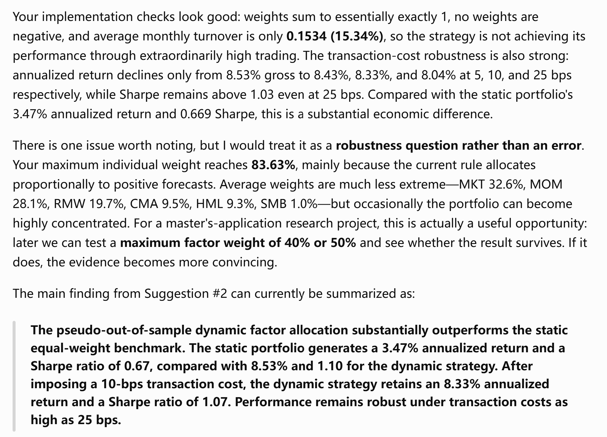
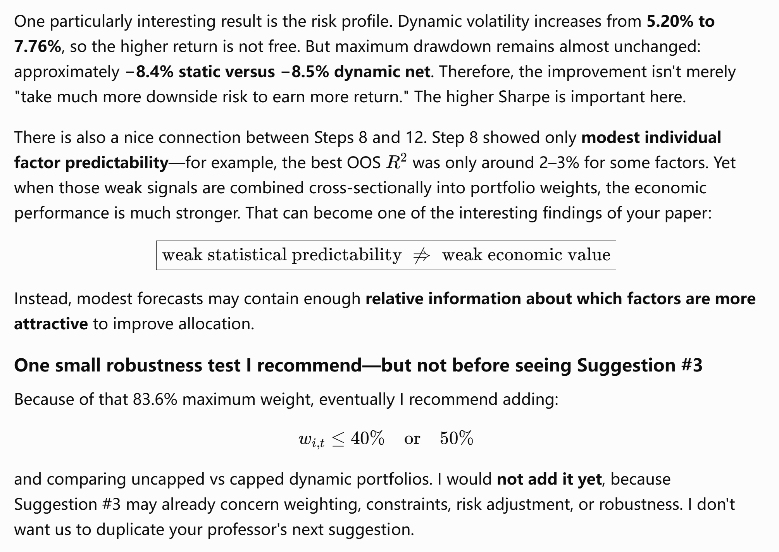

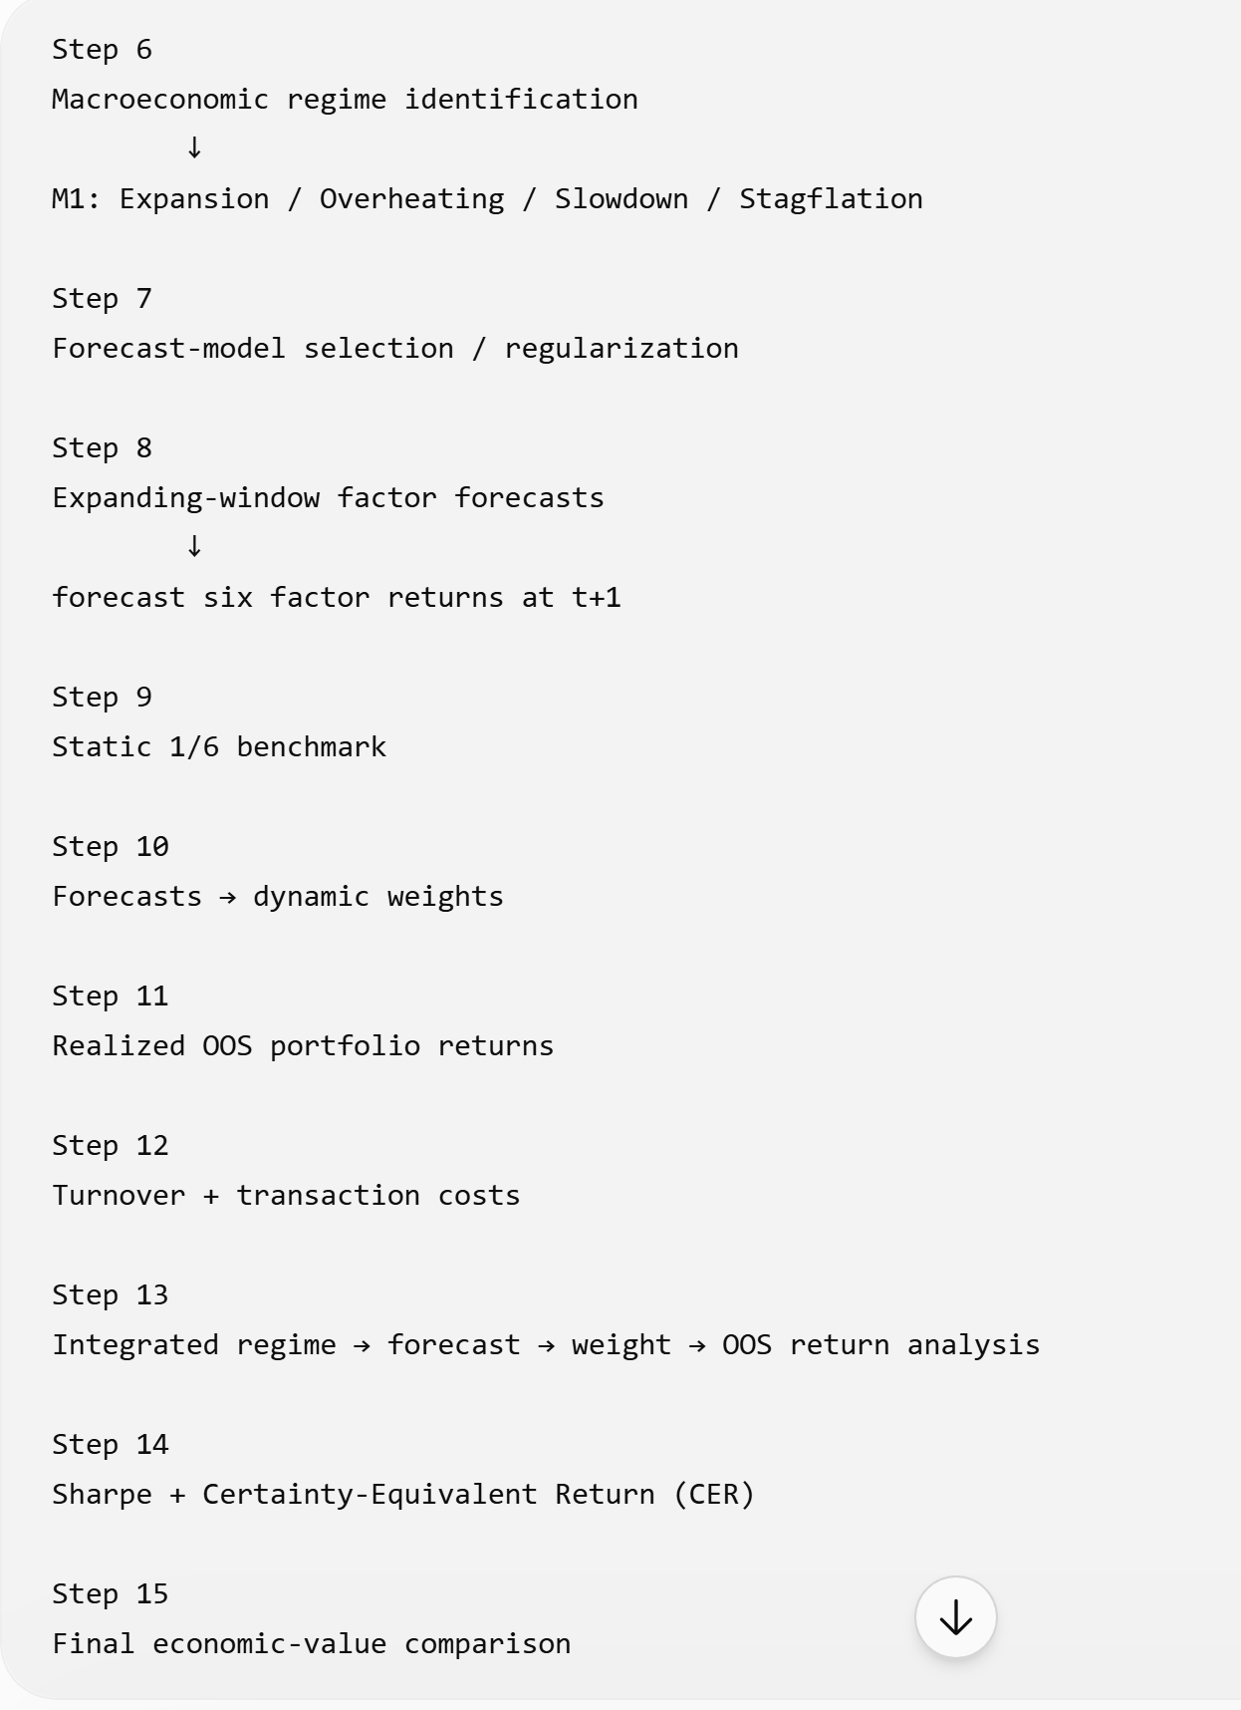
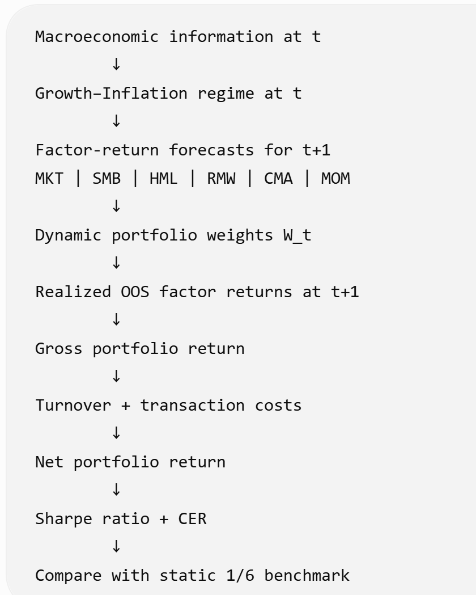

Data:
U.S.
Dataset | Source | Original frequency | Final use | Treatment
VIXCLS.csv | FRED | Daily | VIX | Monthly mean
BAA10Y.csv | FRED | Daily | Credit spread | Monthly mean
T10Y2Y.csv | FRED | Daily | Term spread | Monthly mean
DGS2.csv | FRED | Daily | 2-year Treasury | Monthly mean, then first difference
CPIAUCSL.csv | FRED | Monthly | Inflation | % monthly change, lag 1
UNRATE.csv | FRED | Monthly | Unemployment | Lag 1
INDPRO.csv | FRED | Monthly | Industrial production growth | % monthly change, lag 1
F-F_Research_Data_5_Factors_2x3.csv | Kenneth French | Monthly | MKT-RF, SMB, HML, RMW, CMA, RF | Monthly factor returns
F-F_Momentum_Factor.csv | Kenneth French | Monthly | MOM | Monthly momentum return

Method:
- Historical-mean benchmark
→ 2. HAC/Newey-West predictive regressions
→ 3. PCA robustness
→ 4. Macro regime classification
→ 5. Ridge/Elastic Net
→ 6. Expanding-window OOS
→ 7. Static vs adaptive portfolios
→ 8. Turnover/transaction costs
→ 9. Robustness + placebo/permutation.
Reference
- Amit Goyal, Ivo Welch, Athanasse Zafirov, A Comprehensive 2022 Look at the Empirical Performance of Equity Premium Prediction, The Review of Financial Studies, Volume 37, Issue 11, November 2024, Pages 3490–3557, https://doi.org/10.1093/rfs/hhae044

- Andrew Ang, Trends and Cycles of Style Factors in the 20th and 21st Centuries, The Journal of Portfolio Management Quantitative Special Issue 2023, 49 ( 2) 33 - 56, DOI: 10.3905/jpm.2022.1.455

- Anastasios Kagkadis, Ingmar Nolte, Sandra Nolte, Nikolaos Vasilas, Factor Timing with Portfolio Characteristics, The Review of Asset Pricing Studies, Volume 14, Issue 1, March 2024, Pages 84–118, https://doi.org/10.1093/rapstu/raad010

- Cont, R., & da Fonseca, J. (2002). Dynamics of implied volatility surfaces. Quantitative Finance, 2(1), 45–60. https://doi.org/10.1088/1469-7688/2/1/304

- Dumas, B., Fleming, J., & Whaley, R. E. (1998). Implied Volatility Functions: Empirical Tests. The Journal of Finance, 53(6), 2059–2106. http://www.jstor.org/stable/117461

- DeMIGUEL, V., MARTÍN-UTRERA, A. and UPPAL, R. (2024), A Multifactor Perspective on Volatility-Managed Portfolios. J Finance, 79: 3859-3891. https://doi.org/10.1111/jofi.13395

- DeMiguel, V., Garlappi, L., & Uppal, R. (2009). Optimal versus Naive Diversification: How Inefficient Is the 1/N Portfolio Strategy? The Review of Financial Studies, 22(5), 1915–1953. http://www.jstor.org/stable/30226017

- Diego Mendez-Carbajo, “Data Revisions with FRED®,” Federal Reserve Bank of St. Louis Page One Economics, Aug. 1, 2022. https://www.stlouisfed.org/publications/page-one economics/2022/08/01/data-revisions-with-fred?utm_source=chatgpt.com

- Haddad, V., Kozak, S., & Santosh, S. (2020). Factor Timing. The Review of Financial Studies, 33(5), 1980–2018. https://www.jstor.org/stable/48574456

- Kritzman, M., C.F.A., Page, S., & Turkington, D., C.F.A. (2010). In Defense of Optimization: The Fallacy of 1/N. Financial Analysts Journal, 66(2), 31-39,1. https://www.proquest.com/scholarly-journals/defense-optimization-fallacy-1-n/docview/219229827/se-2

- Lehnherr, R., CFA, Mehta, M., & Nagel, S. (2025). Optimal Factor Timing in a High-Dimensional Setting. Financial Analysts Journal, 81(2), 51–66. https://doi.org/10.1080/0015198X.2025.2474385

- Patrick Schwarz, On the performance of volatility-managed equity factors — International and further evidence, Journal of Empirical Finance, Volume 80, 2025,101560,ISSN 0927-5398, https://doi.org/10.1016/j.jempfin.2024.101560.

- Shu, Y., & Mulvey, J. M. (2025). Dynamic Factor Allocation Leveraging Regime-Switching Signals. Journal of Portfolio Management, 51(3), 50–72.
DOI: 10.3905/jpm.2024.1.649

- Yu, C., Mulvey, J. M., & Nie, Y. (2026). Allocation-Focused Regimes and Applications to Dynamic Factor Investing. Journal of Portfolio Management, 52(5), 96–113.

